
Lincoln High School Activities
Phil Chia, Activities Director
Baley Johnson, Assistant Activities Director
Kristy Waltz, Assistant Activities Director
Heidi Evans, Activities Secretary

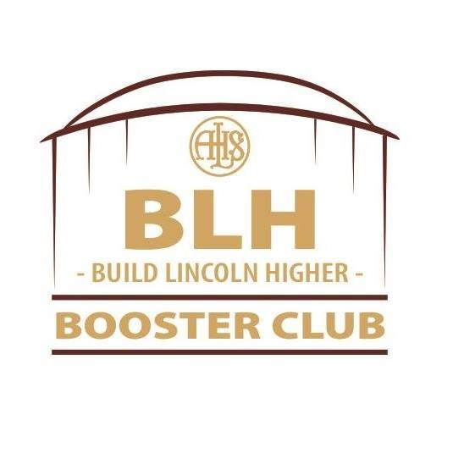

Dear Friends and Alumni of Lincoln High School:

Please join us for the 34th Annual Bob Vanderlinden Golf Outing. For over two decades, Bob tirelessly served Lincoln High school as a coach and athletic director. His presence still remains in our community through the thousands of students he led along the way. This annual event was created to honor Bob’s legacy of service by raising funds to directly support the activities at LHS. It also provides our alumni and supporters the opportunity to catch up for a day on the golf course. This year’s event is scheduled for Friday, June 12, 2026, at A.H. Blank Golf Course.

Did you know that Lincoln High School’s athletics and activities are almost entirely dependent on revenue generated from admission to events, student activity passes, and support from the Build Lincoln Higher Booster Club and fundraisers like this? Proceeds from the Golf Outing have gone directly toward purchasing uniforms and equipment, and making school improvements to increase student achievement. We hope that you will join us for this celebration and consider being a sponsor of this worthy cause.

We have many ticket options available for those individuals and businesses who would like to participate, including:

Dinner Sponsor – $3500 includes golf and dinner for two foursomes, a course sign, and a banner
Eagle Sponsor – $2000 includes golf and dinner for two foursomes and a course sign
Birdie Sponsor – $1200 includes golf and dinner for one foursome and a course sign
Par Sponsor – $600 includes golf and dinner for two golfers and a course sign
Hole Sponsor – $300 includes golf and dinner for one golfer and a course sign
Individual golf tickets ($130) and Foursome tickets ($520) are also available. Both options include dinner.

We have sponsorship opportunities for non-golfers as well! If you are interested in participating and/or becoming a sponsor, please visit our registration site: https://onecau.se/lhsgolf2026.

You may also email president@buildlincolnhigher.com for more information.

Thank you for your continued support of Lincoln High School. Go, Rails!

Sincerely,
Phil Chia Lucy Miller
Lincoln High School Activities Director Build Lincoln Higher President

Patty Bucklin, Job Cooper, Kris Cooper, Gary Dickey, Joel Drake, Heidi Evans, Roberta Nigro
Committee Members

